Fidelity Investments Case

**Case Question**

* Why does it matter how Fidelity BCGF generates additional profit from customers? Won’t people treat dollars the same whether they have to pay them in an upfront load or annual expense ratio?  
  + The way how BCGF generates additional profit will definitely affect company’s pricing decisions. And this will indirect or perhaps direct impact customer purchasing decisions. If we charge more than customers willingness to pay, then customers will choose to buy from our competitors. Therefore, finding a price which can maximise our profit is important.
  + People usually prefer “**separate gain and integrated loss**”. In our case, charging the fee is considered as “loss”. Under this scenario, charging a front-end load might have different effect from charging annual expense even though in the end the fee amount would be the same. **People like to pay upfront and don’t want to be reminded for recurring fee**.
* Does the strength of the Fidelity brand name insulate the fund from price competition with Vanguard’s PRIMECAP fund? Why or why not?  
  + I think “brand” might be one of competitive advantages that Fidelity has over other competitors and therefore they have “some” pricing power to charge additional fees from their customers. However, should also be cautious, if charging over customers willingness to pay, no matter how big / famous your brand is, customers will still switch to other competitors.
* What does the conjoint analysis suggest would be the best way for BCGF to generate the 30 percent increase in profit expected by Johnson?  
    
  Customer willingness to pay for each company (numbers are get from conjoint analysis)

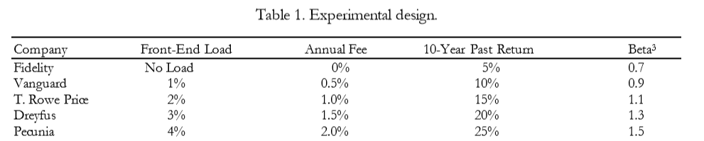

Fidelity: 0.08+0.88+0.99-1.23+0.05=0.77

Vanguard: 0.01+0.48+0.5-0.7+0.06=0.35

T: 0.08+0.05+0.05-0.06+0.13=0.37

Dreyfus: 0-0.25-0.07+0.76-0.1=0.34

Pecunia: -0.17-0.67-0.74+1.23-0.14=-0.49

Among these five companies, **Fidelity has the highest customers willingness to pay** for their product. To leverage on this, Fidelity can modify their pricing strategies (ex: charging additional fee like front-end load and annual fee).

**Outline two different approaches**

* Charging Front-end Load only
* Increasing annual expense only
* Charging Front-end load + Increasing annual expense -> since method 2 alone make the willingness to pay lower than our competitor (0.28 < 0.35), this method definitely will make things even worse

|  |  |  |  |
| --- | --- | --- | --- |
| **Approaches** | **WTP** | **Vanguard (benchmark)** | **Difference** |
| Charging Front-end Load only |  |  |  |
| 1 % | 0.37 | 0.35 | +0.02 |
| 2 % | -0.06 | 0.35 | (-0.41) |
| Increasing annual expense only |  |  |  |
| 0.5 % | 0.28 | 0.35 | (-0.07) |

**Recommend a specific course of action (products and prices)**

Given above analysis, Fidelity can only use **approach 1** which is **charging front-end load 1%** more than current situation. By doing so, our customer willingness to pay still higher than our competitor by 0.02. But to justify whether this strategy can optimize company’s profit, we need more detail market analysis to determine since given current data point we are not able to know what’s our customer price elasticity and how market demand will react according to the new price schema.